**Task 1:**

#include<iostream>

using namespace std;

int main()

{

char arr[100];

cout << "Enter a string having less than 100 characters.\n";

cin.getline(arr, 100);

int count = 0;

for (int i = 0; arr[i] != '\0'; i++)

{

count++;

}

if (count % 2 == 0)

{

cout << "Length is "<<count<<endl;

for (int i = 0, j = count - 1; i < count / 2; i++, j--)

{

int swap = arr[i];

arr[i] = arr[j];

arr[j] = swap;

}

cout << "String is "<<arr << endl;

}

else

{

cout << "Length is " << count << endl;

for (int i = 0; i < count - 1; i++)

{

for (int j = 0; j < count - 1 - i; j++)

{

if (arr[j]>arr[j + 1])

{

int swap = arr[j];

arr[j] = arr[j + 1];

arr[j + 1] = swap;

}

}

}

cout << "String is " << arr << endl;

}

return 0;

}

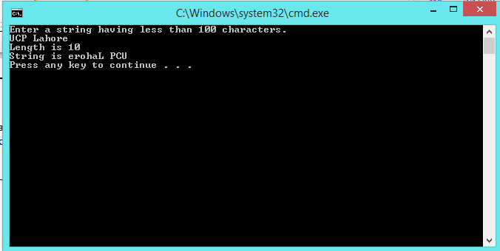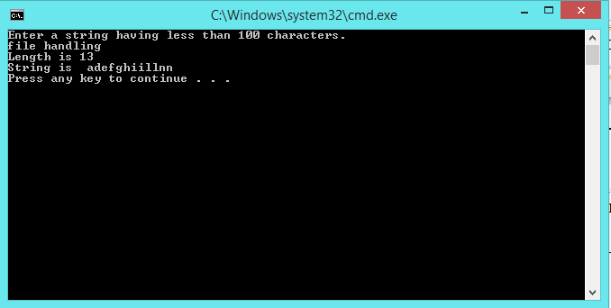

**Task 2:**

#include<iostream>

#include<fstream>

using namespace std;

int main()

{

ofstream fout1;

fout1.open("input.txt");

if (!fout1)

{

cout << "File opening operation failed";

}

else

{

fout1 << "This is a string which contains vowels and consonants. Our task is to sort them in descending order, and print their count.";

}

fout1.close();

ifstream fin;

int c = 0, v = 0, a = 0, e = 0, i = 0, o = 0, u = 0;

int index = 0;

char arr[1000];

char vowels[100];

fin.open("input.txt");

if (!fin)

{

cout << "File does not exist.";

}

else

{

fin.getline(arr, 1000, fin.eof());

cout << arr << endl;

for (int j = 0; arr[j] != '\0'; j++)

{

if (arr[j] == 'a' || arr[j] == 'A')

{

a++;

vowels[index++]=arr[j];

}

else if (arr[j] == 'e' || arr[j] == 'E')

{

e++;

vowels[index++] = arr[j];

}

else if (arr[j] == 'i' || arr[j] == 'I')

{

i++;

vowels[index++] = arr[j];

}

else if (arr[j] == 'o' || arr[j] == 'O')

{

o++;

vowels[index++] = arr[j];

}

else if (arr[j] == 'u' || arr[j] == 'U')

{

u++;

vowels[index++] = arr[j];

}

else if (arr[j] >= 'b' && arr[j] <= 'd' || arr[j] >= 'f' && arr[j] <= 'h' || arr[j] >= 'j' && arr[j] <= 'n' || arr[j] >= 'p' && arr[j] <= 't' || arr[j] >= 'v' && arr[j] <= 'z')

c++;

else if (arr[j] >= 'B' && arr[j] <= 'D' || arr[j] >= 'F' && arr[j] <= 'H' || arr[j] >= 'J' && arr[j] <= 'N' || arr[j] >= 'P' && arr[j] <= 'T' || arr[j] >= 'V' && arr[j] <= 'Z')

c++;

}

v = a + e + i + o + u;

}

vowels[index] ='\0';

fin.close();

ofstream fout2;

fout2.open("output.txt");

if (!fout2)

{

cout << "File opening operation failed.";

}

else

{

fout2 << "Total Consonants: "<<c<<endl;

fout2 << "Total Vowels: "<<v<<endl;

fout2 << "Total 'i' " << i << endl;

fout2 << "Total 'o' " << o << endl;

fout2 << "Total 'a' " << a << endl;

fout2 << "Total 'e' " << e << endl;

fout2 << "Total 'u' " << u << endl;

cout << "Total Consonants: " << c << endl;

cout << "Total Vowels: " << v << endl;

cout << "Total 'i' " << i << endl;

cout << "Total 'o' " << o << endl;

cout << "Total 'a' " << a << endl;

cout << "Total 'e' " << e << endl;

cout << "Total 'u' " << u << endl;

for (int j = 0; j < index - 1; j++)

{

for (int k = 0; k < index - 1 - j; k++)

{

if (vowels[k] < vowels[k + 1])

{

int swap = vowels[k];

vowels[k] = vowels[k + 1];

vowels[k + 1] = swap;

}

}

}

cout << "Descended sorted array is\n"<<vowels;

fout2 << "Descended sorted array is\n" << vowels;

index = 0;

for (int j = 0; arr[j] != 0; j++)

{

if (arr[j] == 'a' || arr[j] == 'e' || arr[j] == 'i' || arr[j] == 'o' || arr[j] == 'u' || arr[j] == 'A' || arr[j] == 'E' || arr[j] == 'I' || arr[j] == 'O' || arr[j] == 'U')

arr[j] = vowels[index++];

}

cout << "\nPutting descended sorted array in original array" << endl<<arr<<endl;

fout2 << "\nPutting descended sorted array in original array" << endl<<arr<<endl;

}

fout2.close();

return 0;

}

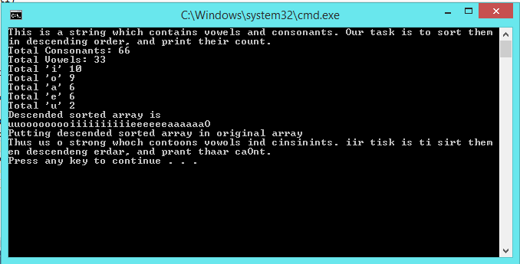

**Task 3:**

#include<iostream>

#include<fstream>

using namespace std;

int main()

{

ofstream fout1;

fout1.open("students.txt");

if (!fout1)

{

cout << "File opening operation failed.";

}

else

{

fout1 << "FA21 - BCS - 110\nFA20 - BCS - 122\nSP21 - BSE - 134\nFA21 - BCS - 137\nFA21 - BSE - 145";

}

fout1.close();

ifstream fin;

ofstream fout2;

fin.open("students.txt");

fout2.open("records.txt");

if (!fin || !fout2)

{

cout << "I/0 operation failed.";

}

else

{

char arr[100];

fout2 << "Semester\t Program\t Roll No."<<endl;

cout << "Semester\tProgram\t\tRoll No."<<endl;

while (!fin.eof())

{

fin.getline(arr, 100, '-');

cout << arr<<"\t\t\b";

fout2 << arr << "\t\t";

}

}

cout << endl;

return 0;

}

